Business Formation Proposal
Date: {{ date }}

Business Activity | {{ business_name }}
License Authority | Sharjah Media City (SHAMS)



Sharjah Media City (Shams) a digitally born free zone authority was launched after an Emiri Decree was issued in 2017, by His Highness Sheikh Dr. Sultan Bin Muhammad Al Qasimi, Supreme Council Member and Ruler of Sharjah. With an infrastructure that emulates international standards, Shams aims to be a regional leader across fields of media and creativity whilst providing a variety of resources to generate high-quality content. Their services are curated to create cost-effective solutions for SMEs, established companies and freelancers that can help them easily embark on their entrepreneurial journey.

Approximate Costing of Company Incorporation

Business Formation -SHAMS
Particulars | AED | USD
{{#items}}{{label}} | {{amount}} | $ {{amount_usd}}{{/items}}
Total | {{total}} | $ {{total_usd}}

Package Includes:
- Business License
- Flexi Desk agreement
- Certificate of formation
- Share percentage Certificate

***Please note: - process will start after confirmation of payment, POP must be sent to a designated member)

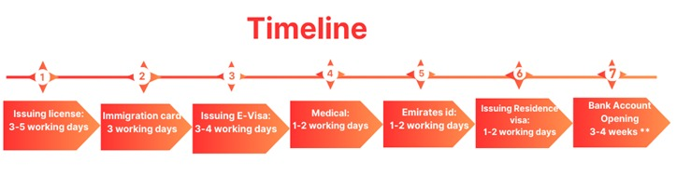
Add-on services provided by AB Capital

Add-on Services
Particulars | AED | USD
VAT Registration | 750 | 203
Corporate Tax Registration | 500 | 136
VAT Filing (Based on number of transaction) | 750 | 205
Accounting Services (Less than 10 transactions per month) | 700 | 190
Accounting Services (10 to 20 transactions per month) | 1000 | 274
Accounting Services (20 to 30 transactions per month) | 1200 | 330
Accounting Services (30 to 50 transactions per month) | 1500 | 410
Accounting Services (More than 50 transactions per month) | Rate will be customized | Rate will be customized

Terms & Conditions:

Documents Required

- Full Spread & Uncut Passport of the owner/partners & resident page (if any)
- High Resolution Passport size photo (white background only)
- Minimum 3 company names options
- Email ID of Investor/Partner
- Active Contact Number and address of Partners.

Payment Terms

- 100% down payment to start the process

Scope of work

- Preparation & Submission of Application
- Assisting clients in submitting the KYC and accepting the application
- Issuing Trade License and legal documents.
- Submitting application for immigration card
- Submitting application for visas
- Assisting client for medical & emirates id
- Preparation of documents for bank account

Notes:
- The license fee is calculated based on the free zone authority price chart.
- All Government and Regulatory charges are borne by the Customer on an actual basis.
- Above are indicative charges current based on current promotions and might be variable.
- More than one business Activities should be from same field or extra charges will be applied as per authority.
- Branch company activity should match with the parent company.

- Depending on the nature of your business activity, you may need to submit additional documents to obtain approvals from other government bodies.
- *Plus, Applicable Taxes.

Contact: - Bharat Bajaj

+971-523655193

info@abcapital.ae www.abcapital.ae

